# Coding Challenge SQL

**Virtual Art Gallery Shema DDL and DML**

-- Create the Artists table CREATE TABLE Artists (

ArtistID INT PRIMARY KEY,

Name VARCHAR(255) NOT NULL,

Biography TEXT,

Nationality VARCHAR(100));

-- Create the Categories table CREATE TABLE Categories (

CategoryID INT PRIMARY KEY, Name VARCHAR(100) NOT NULL);

-- Create the Artworks table CREATE TABLE Artworks (

ArtworkID INT PRIMARY KEY, Title VARCHAR(255) NOT NULL,

ArtistID INT, CategoryID INT, Year INT,

Description TEXT,

ImageURL VARCHAR(255),

FOREIGN KEY (ArtistID) REFERENCES Artists (ArtistID),

FOREIGN KEY (CategoryID) REFERENCES Categories (CategoryID));

-- Create the Exhibitions table CREATE TABLE Exhibitions (

ExhibitionID INT PRIMARY KEY, Title VARCHAR(255) NOT NULL,

StartDate DATE, EndDate DATE,

Description TEXT);

-- Create a table to associate artworks with exhibitions CREATE TABLE ExhibitionArtworks (

ExhibitionID INT, ArtworkID INT,

PRIMARY KEY (ExhibitionID, ArtworkID),

FOREIGN KEY (ExhibitionID) REFERENCES Exhibitions (ExhibitionID), FOREIGN KEY (ArtworkID) REFERENCES Artworks (ArtworkID));

# DML(Insert sample data to tables)

-- Insert sample data into the Artists table

INSERT INTO Artists (ArtistID, Name, Biography, Nationality) VALUES

(1, 'Pablo Picasso', 'Renowned Spanish painter and sculptor.', 'Spanish'), (2, 'Vincent van Gogh', 'Dutch post-impressionist painter.', 'Dutch'),

(3, 'Leonardo da Vinci', 'Italian polymath of the Renaissance.', 'Italian');

-- Insert sample data into the Categories table

INSERT INTO Categories (CategoryID, Name) VALUES (1, 'Painting'),

(2, 'Sculpture'),

(3, 'Photography');

-- Insert sample data into the Artworks table

INSERT INTO Artworks (ArtworkID, Title, ArtistID, CategoryID, Year, Description, ImageURL) VALUES (1, 'Starry Night', 2, 1, 1889, 'A famous painting by Vincent van Gogh.', 'starry_night.jpg'),

(2, 'Mona Lisa', 3, 1, 1503, 'The iconic portrait by Leonardo da Vinci.', 'mona_lisa.jpg'), (3, 'Guernica', 1, 1, 1937, 'Pablo Picasso\'s powerful anti-war mural.', 'guernica.jpg');

-- Insert sample data into the Exhibitions table

INSERT INTO Exhibitions (ExhibitionID, Title, StartDate, EndDate, Description) VALUES

(1, 'Modern Art Masterpieces', '2023-01-01', '2023-03-01', 'A collection of modern art masterpieces.'), (2, 'Renaissance Art', '2023-04-01', '2023-06-01', 'A showcase of Renaissance art treasures.');

-- Insert artworks into exhibitions

INSERT INTO ExhibitionArtworks (ExhibitionID, ArtworkID) VALUES (1, 1),

(1, 2),

(1, 3),

(2, 2);

# Solve the below queries:

1. Retrieve the names of all artists along with the number of artworks they have in the gallery, and list them in descending order of the number of artworks.
2. List the titles of artworks created by artists from 'Spanish' and 'Dutch' nationalities, and order them by the year in ascending order.
3. Find the names of all artists who have artworks in the 'Painting' category, and the number of artworks they have in this category.
4. List the names of artworks from the 'Modern Art Masterpieces' exhibition, along with their artists and categories.
5. Find the artists who have more than two artworks in the gallery.
6. Find the titles of artworks that were exhibited in both 'Modern Art Masterpieces' and 'Renaissance Art' exhibitions
7. Find the total number of artworks in each category
8. List artists who have more than 3 artworks in the gallery.
9. Find the artworks created by artists from a specific nationality (e.g., Spanish).
10. List exhibitions that feature artwork by both Vincent van Gogh and Leonardo da Vinci.
11. Find all the artworks that have not been included in any exhibition.
12. List artists who have created artworks in all available categories.
13. List the total number of artworks in each category.
14. Find the artists who have more than 2 artworks in the gallery.
15. List the categories with the average year of artworks they contain, only for categories with more

than 1 artwork.

1. Find the artworks that were exhibited in the 'Modern Art Masterpieces' exhibition.
2. Find the categories where the average year of artworks is greater than the average year of all artworks.

18. List the artworks that were not exhibited in any exhibition.

1. Show artists who have artworks in the same category as "Mona Lisa."
2. List the names of artists and the number of artworks they have in the gallery.

ANSWERS

1.

select Artists.Name , count(ExhibitionArtworks.ArtworkID) as countart

from Artists

join Artworks on Artworks.ArtistID = Artists.ArtistID

join ExhibitionArtworks on ExhibitionArtworks.ArtworkID=Artworks.ArtworkID

group by Artists.Name

order by countart desc;

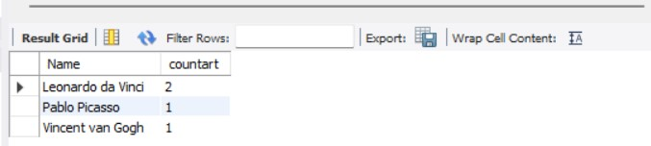

2.

SELECT Artworks.Title

FROM Artworks

JOIN Artists ON Artworks.ArtistID = Artists.ArtistID

WHERE Artists.Nationality IN ('Spanish', 'Dutch')

ORDER BY Artworks.Year ASC;

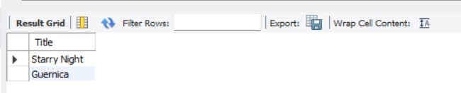

3.

SELECT Artists.Name AS ArtistName, COUNT(Artworks.ArtworkID) AS NumberOfArtworks

FROM Artists

JOIN Artworks ON Artists.ArtistID = Artworks.ArtistID

JOIN Categories ON Artworks.CategoryID = Categories.CategoryID

WHERE Categories.Name = 'Painting'

GROUP BY Artists.ArtistID, Artists.Name;

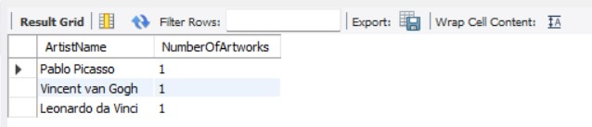

4.

select Artworks.title as title,Artists.Name as author,Categories.Name as Cat

from Artists

join Artworks on Artists.ArtistID=Artworks.ArtistID

join ExhibitionArtworks on Artworks.ArtworkID = ExhibitionArtworks.ArtworkID

join Categories on Categories.CategoryID = Artworks.CategoryID

where ExhibitionArtworks.ExhibitionID=1

group by ExhibitionArtworks.ArtworkID;

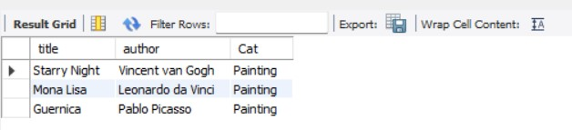

5.

SELECT Artists.Name, COUNT(ExhibitionArtworks.ArtworkID) AS countart

FROM Artists

JOIN Artworks ON Artworks.ArtistID = Artists.ArtistID

JOIN ExhibitionArtworks ON ExhibitionArtworks.ArtworkID = Artworks.ArtworkID

GROUP BY Artists.Name

HAVING countart > 2;

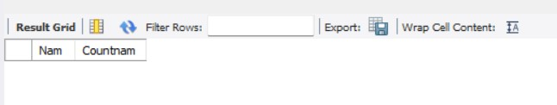

6.

select Artworks.title as titles from Artworks

join ExhibitionArtworks on ExhibitionArtworks.ArtworkID = Artworks.ArtworkID

where ExhibitionID=1 or ExhibitionID=2

group by Artworks.title having count(distinct ExhibitionID)=2;

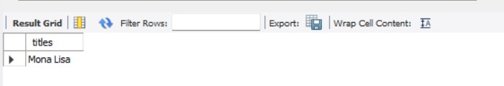

7.

SELECT Categories.Name AS CategoryName, COUNT(Artworks.ArtworkID) AS TotalArtworks

FROM Categories

LEFT JOIN Artworks ON Categories.CategoryID = Artworks.CategoryID

GROUP BY Categories.Name;

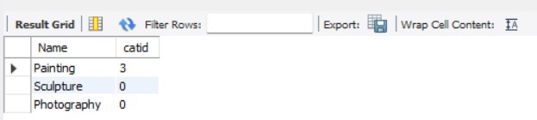

8.

SELECT Artists.Name AS ArtistName

FROM Artists

JOIN Artworks ON Artists.ArtistID = Artworks.ArtistID

GROUP BY Artists.ArtistID, Artists.Name

HAVING COUNT(Artworks.ArtworkID) > 3;

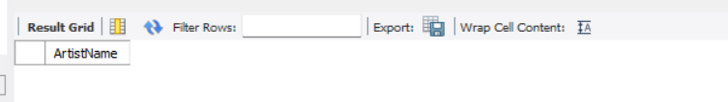

9.

SELECT Artworks.Title

FROM Artworks

JOIN Artists ON Artworks.ArtistID = Artists.ArtistID

WHERE Artists.Nationality = 'Spanish';

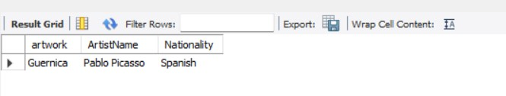

10.

SELECT DISTINCT Exhibitions.Title

FROM Exhibitions

JOIN ExhibitionArtworks ON Exhibitions.ExhibitionID = ExhibitionArtworks.ExhibitionID

JOIN Artworks ON ExhibitionArtworks.ArtworkID = Artworks.ArtworkID

JOIN Artists ON Artworks.ArtistID = Artists.ArtistID

WHERE Artists.Name = 'Vincent van Gogh' OR Artists.Name = 'Leonardo da Vinci'

GROUP BY Exhibitions.Title

HAVING COUNT(DISTINCT Artists.Name) = 2;

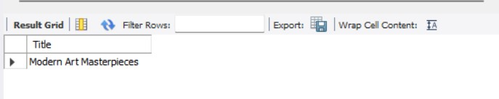

11.

SELECT Artworks.Title

FROM Artworks

LEFT JOIN ExhibitionArtworks ON Artworks.ArtworkID = ExhibitionArtworks.ArtworkID

WHERE ExhibitionArtworks.ArtworkID IS NULL;

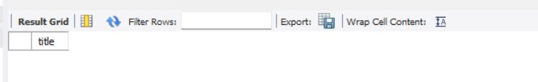

12.

SELECT Artists.Name AS ArtistName

FROM Artists

JOIN Artworks ON Artists.ArtistID = Artworks.ArtistID

JOIN Categories ON Artworks.CategoryID = Categories.CategoryID

GROUP BY Artists.ArtistID, Artists.Name

HAVING COUNT(DISTINCT Categories.CategoryID) = (SELECT COUNT(*) FROM Categories);

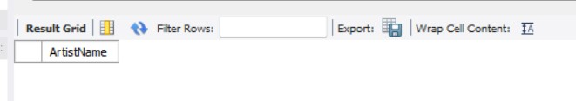

13.

SELECT Categories.Name AS CategoryName, COUNT(Artworks.ArtworkID) AS TotalArtworks

FROM Categories

LEFT JOIN Artworks ON Categories.CategoryID = Artworks.CategoryID

GROUP BY Categories.Name;

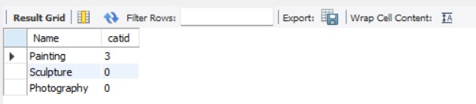

14.

SELECT Artists.Name, COUNT(ExhibitionArtworks.ArtworkID) AS countart

FROM Artists

JOIN Artworks ON Artworks.ArtistID = Artists.ArtistID

JOIN ExhibitionArtworks ON ExhibitionArtworks.ArtworkID = Artworks.ArtworkID

GROUP BY Artists.Name

HAVING countart > 2;

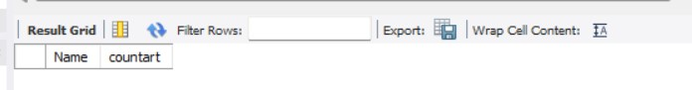

15.

SELECT Categories.Name AS CategoryName, AVG(Artworks.Year) AS AverageYear

FROM Artworks

JOIN Categories ON Artworks.CategoryID = Categories.CategoryID

GROUP BY Categories.CategoryID, Categories.Name

HAVING COUNT(Artworks.ArtworkID) > 1;

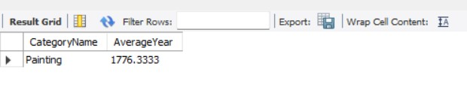

16.

SELECT Artworks.Title

FROM Artworks

JOIN ExhibitionArtworks ON Artworks.ArtworkID = ExhibitionArtworks.ArtworkID

JOIN Exhibitions ON ExhibitionArtworks.ExhibitionID = Exhibitions.ExhibitionID

WHERE Exhibitions.Title = 'Modern Art Masterpieces';

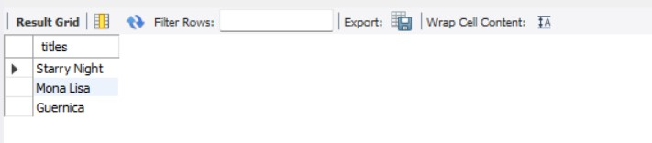

17.

SELECT Categories.Name AS CategoryName

FROM Categories

JOIN Artworks ON Categories.CategoryID = Artworks.CategoryID

GROUP BY Categories.CategoryID, Categories.Name

HAVING AVG(Artworks.Year) > (

SELECT AVG(Year)

FROM Artworks

);

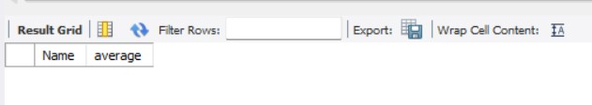

18.

SELECT Artworks.Title

FROM Artworks

LEFT JOIN ExhibitionArtworks ON Artworks.ArtworkID = ExhibitionArtworks.ArtworkID

WHERE ExhibitionArtworks.ArtworkID IS NULL;



19.

SELECT DISTINCT Artists.Name AS ArtistName

FROM Artists

JOIN Artworks ON Artists.ArtistID = Artworks.ArtistID

JOIN Categories ON Artworks.CategoryID = Categories.CategoryID

WHERE Categories.CategoryID IN (

SELECT CategoryID

FROM Artworks

WHERE Title = 'Mona Lisa'

) AND Artists.ArtistID != (

SELECT ArtistID

FROM Artworks

WHERE Title = 'Mona Lisa'

);

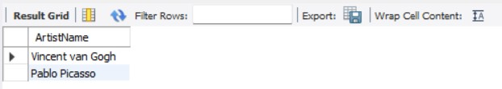

20.

select Artists.Name , count(ExhibitionArtworks.ArtworkID) as countart

from Artists

join Artworks on Artworks.ArtistID = Artists.ArtistID

join ExhibitionArtworks on ExhibitionArtworks.ArtworkID=Artworks.ArtworkID

group by Artists.Name;

